Lab 2: Agile Backlog Creation and Sprint Simulation in Jira
Problem Statement #14, Healthcare and Telemedicine: Corporate Mental Wellness and Counseling Platform
Name | Dhanush Shankar Reddy
SRN | PES1UG24AM083
Section | B
Unique epic | CMW-1, UC-02 Take Stress Self-Assessment

1. Epic
Field | Value
Epic | CMW-1 UC-02 Take Stress Self-Assessment
Description | Let a signed-in employee answer the ten-item stress questionnaire and get a score out of 40 with its band. The answers are stored only against the employee's pseudo-ID, and a severe score brings up crisis help straight away.

2. User stories
Every story uses the format: As a [user role], I want [goal], so that [benefit].
Key | User story | Priority | Points
CMW-3 | Answer the ten questions. As a corporate employee, I want to see all ten questions with a scale from Never (0) to Very Often (4), so that I can say how often each one applies to me. | High | 3
CMW-4 | Block incomplete submissions. As a corporate employee, I want the form to name any question I skipped when I submit, so that my score is never worked out from a half-filled form. | High | 2
CMW-5 | Work out the score and band. As a corporate employee, I want my answers added up to a score out of 40 and placed in the low, moderate, high or severe band, so that the same answers always give me the same reading. | High | 3
CMW-6 | Show the result as a wellness check. As a corporate employee, I want to see my score and band within 2 seconds, with a line saying it is a wellness check and not a diagnosis, so that I know what the number means. | High | 3
CMW-8 | Save the result against my pseudo-ID. As a corporate employee, I want my answers and score saved encrypted against my pseudo-ID only, so that I can look back at them later without anyone tying them to my name. | High | 8
CMW-9 | Show crisis help on a severe score. As a corporate employee whose score is severe, I want helpline details shown above my score and the earliest priority slot within 24 hours offered to me, so that I can get help the same day. | High | 8
CMW-2 | Start the self-assessment. As a corporate employee, I want a 'Check my stress level' option once I am signed in, so that I can check on my stress whenever I want to. | Medium | 2
CMW-7 | Discard a half-finished assessment. As a corporate employee, I want my answers thrown away if I leave before finishing, so that an incomplete set is never scored or shown on my trend. | Medium | 2
CMW-10 | Link to booking from the result. As a corporate employee, I want a link to book a counselling session on my result screen, so that I can act on the result straight away. | Low | 1
 | Total |  | 32

3. Jira screenshots

3.1 Backlog with epic and user stories
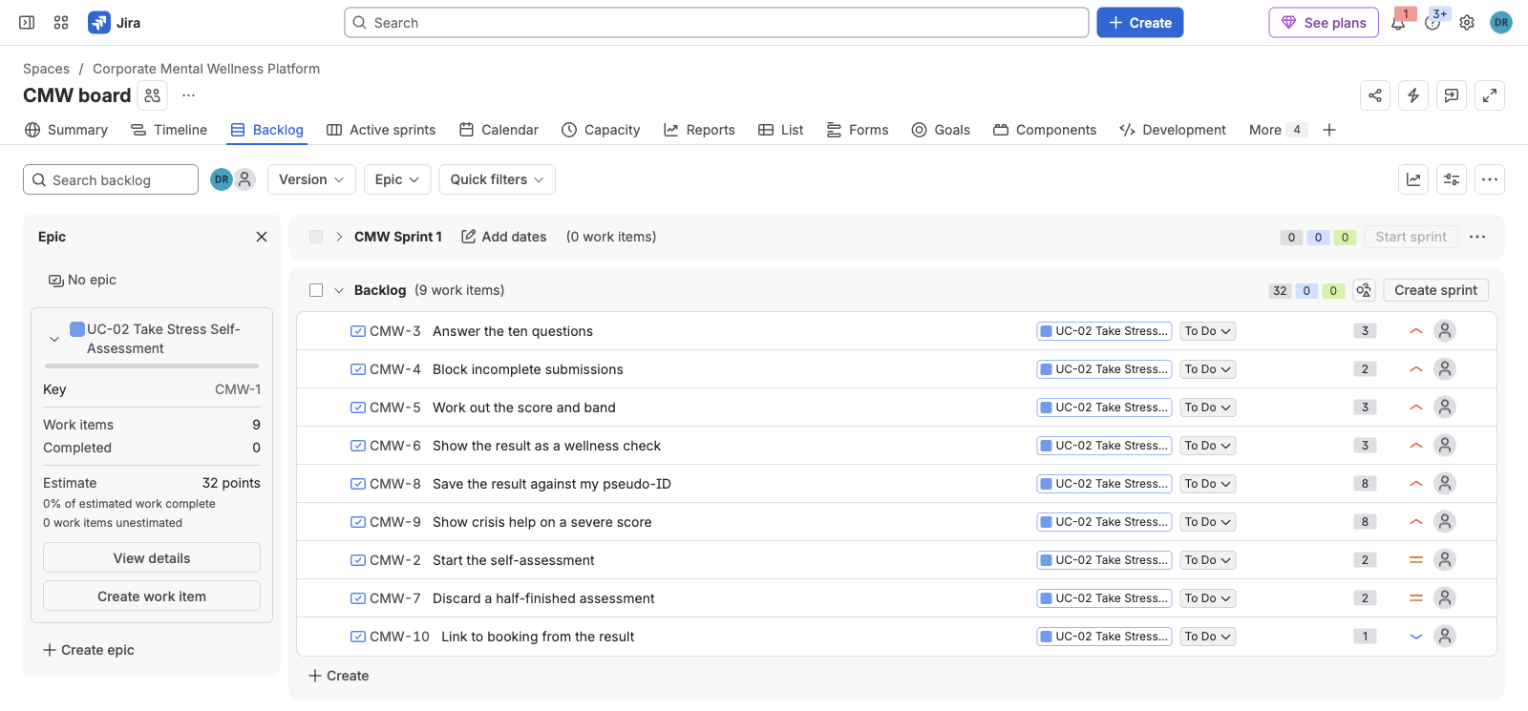
Figure 1. CMW backlog with the epic panel open and the UC-02 user stories, before sprint planning.

3.2 Story point assignments
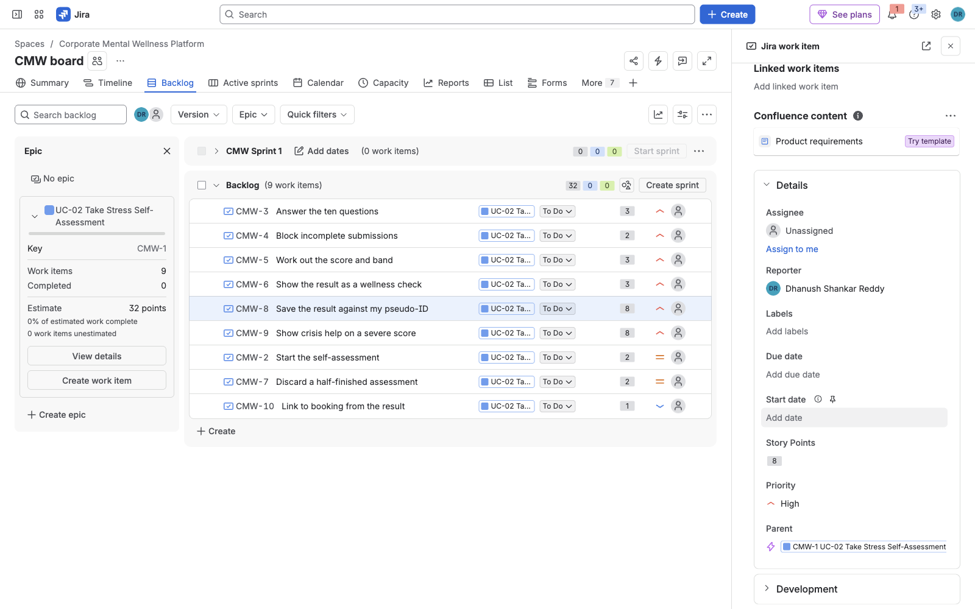
Figure 2. Story points on each story, the Story Points field of CMW-8 and the 32-point epic total.

3.3 Sprint board (active sprint)
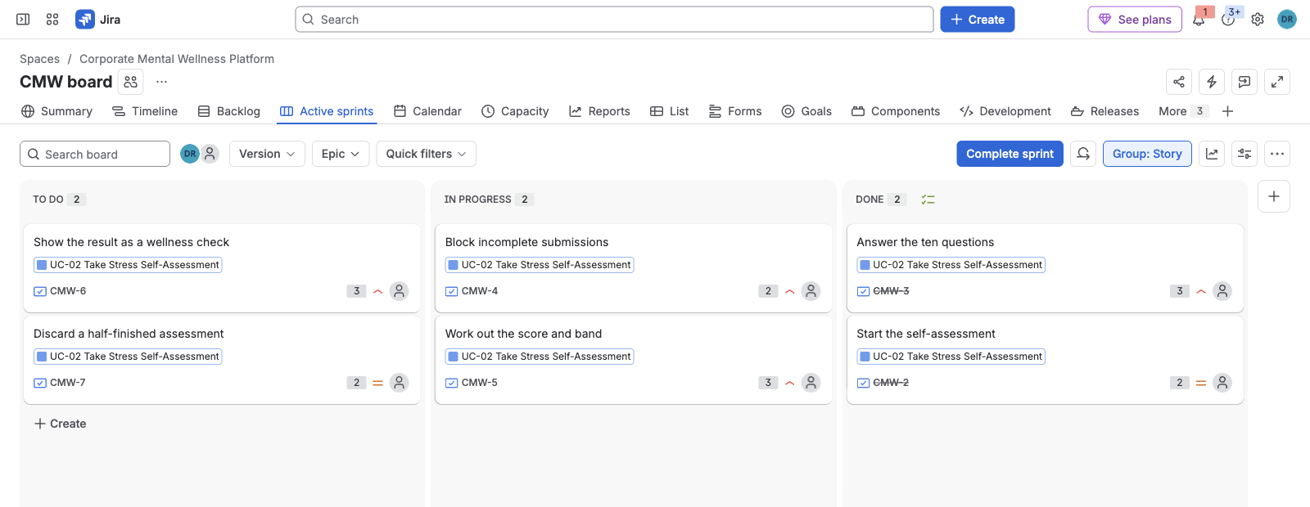
Figure 3. Active sprint board, CMW Sprint 1: two stories in To Do, two in In Progress, two in Done.
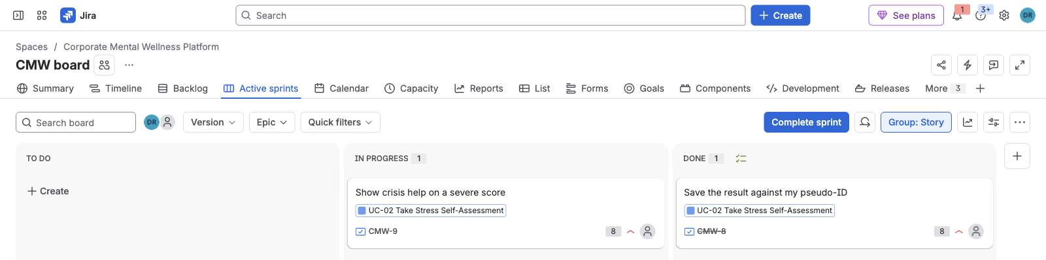
Figure 4. Active sprint board, CMW Sprint 2: CMW-9 in progress, CMW-8 done.

3.4 Burndown charts
Reports > Burndown Chart, estimation statistic Story Points.
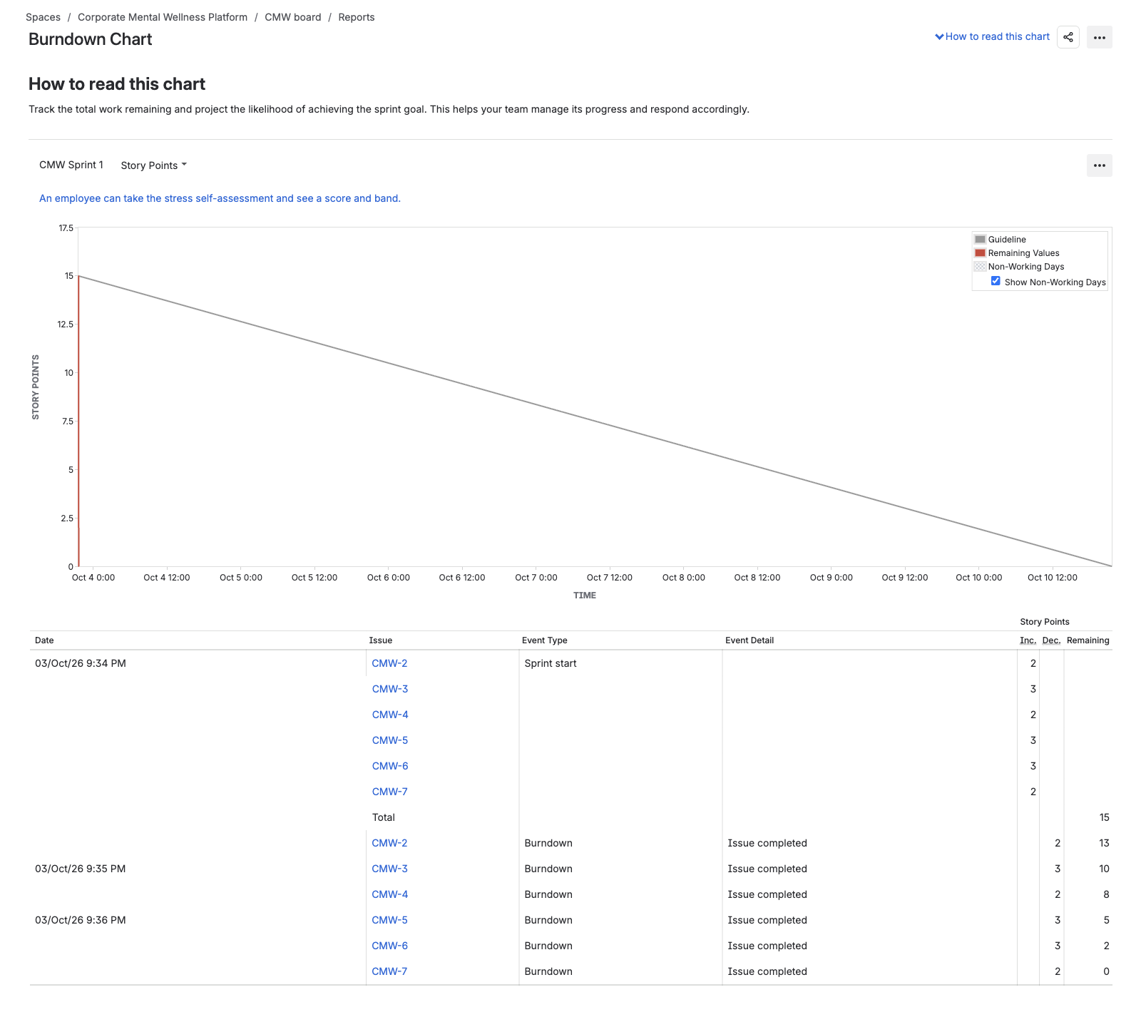
Figure 5. Burndown chart, CMW Sprint 1: 15 points at the start, down to 0.
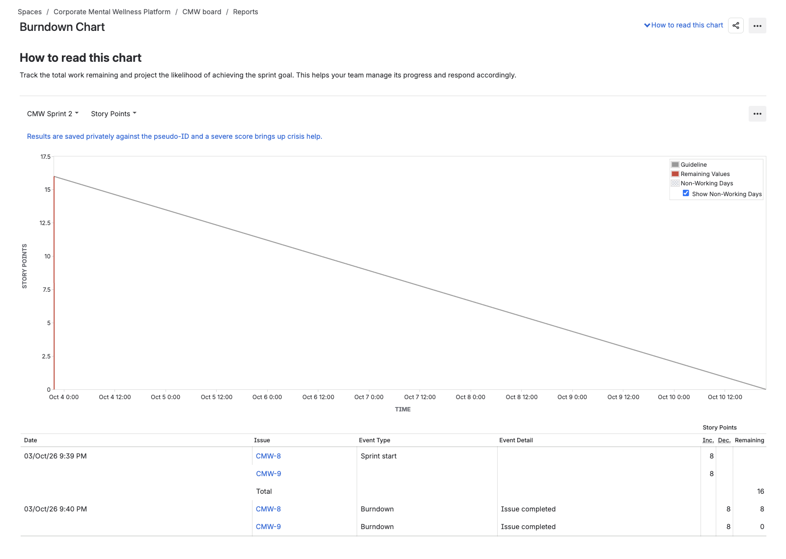
Figure 6. Burndown chart, CMW Sprint 2: 16 points at the start, down to 0.

4. Reflection

1. Did your estimations reflect the actual effort?
Partly. Since this was a simulated sprint and I moved each card by hand, the time a story spent between To Do and Done doesn't say anything about how hard it would actually be to build. What I could check was whether the relative sizes still made sense after writing each story out.
The 1, 2 and 3 point stories held up fine. The two 8-point stories are the ones I'm least sure about. Saving the result against the pseudo-ID could be split into storing the answers and encrypting them, and the crisis panel depends on the booking side because the priority slot has to come from slots a therapist has already published. I kept both as single stories because each maps to one step of the UC-02 flow (main flow step 7 and alternate flow 6a), so the trace back to Lab 1 stays one to one. In a real project I would split them before committing them to a sprint, because if one of them slips, a big part of the sprint slips with it.

2. Was your backlog well-prioritized?
For the most part, yes. Every High story traces to a pass/fail condition in FR-002, FR-005 or NFR-002, so the order follows what the requirements say has to work. The only Low story is the booking link, since UC-03 already covers booking.
The crisis story is where it falls short. It is ranked above the two Medium stories in the backlog, but I put it in Sprint 2 so that Sprint 1 could deliver the full assessment from start to result. That means the Sprint 1 build could show a severe score without the helpline panel, which is exactly the fail condition in FR-005, so that build shouldn't go to real employees. If Sprint 1 needed to be releasable, the crisis story should have gone in before the Medium stories.

3. How did your simulated sprint align with your plan?
Both sprints closed with all committed stories in Done, 15 points in Sprint 1 and 16 in Sprint 2. The booking link stayed in the backlog as planned and nothing was added to either sprint after it started, so there was no scope change. Since I moved all the cards in one sitting, this mainly shows that the board and workflow are set up correctly rather than whether the plan was realistic.

4. What insights did the burndown chart give about your team's capacity?
In both charts the red line drops from the full estimate to 0 within minutes of the sprint starting, well below the grey guideline. Normally that would point to an under-committed sprint, but here it's just because a week of work was run in a few minutes.
The more useful part was the event tables, which show that points only burn when a story reaches Done. In Sprint 1 the line went 15, 13, 10, 8, 5, 2, 0, one step per completed story, and nothing changed while a story was In Progress. So a story stuck in In Progress for four days would keep the line flat that whole time, which is another reason to split the two 8-point stories. For the next sprint I would plan around the 15 to 16 points completed here and adjust once a sprint actually runs over real working days.

